Conclusion 14

Shortest Path

The distance of a vertex v from a vertex s is the length of a shortest path between s and v

The relaxation of edge e updates distance d(z)

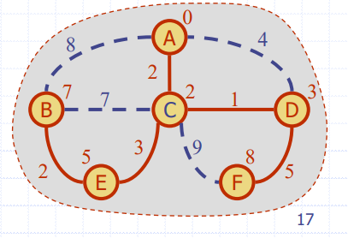

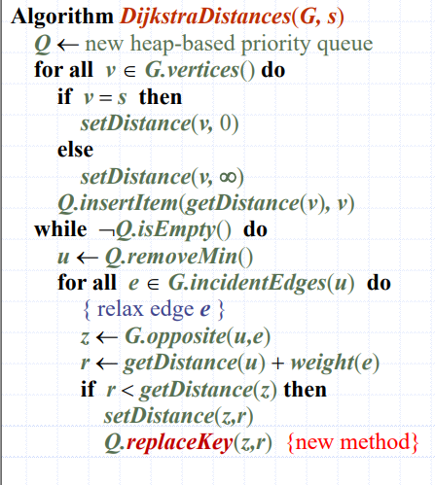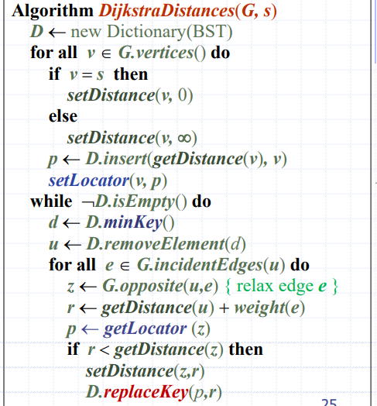

Dijkstra’s algorithm runs in O((n + m) log n) time provided the graph is represented by the adjacency list structure The running time can also be expressed as O(m log n)

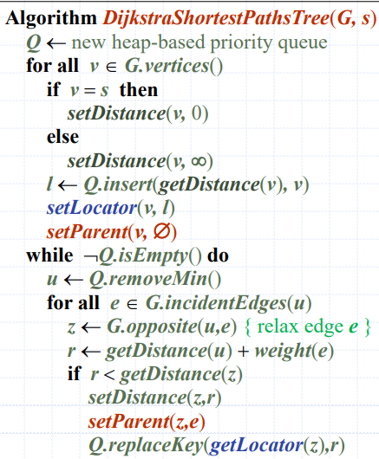

Compare BFS and DFS Hooks

